Environment set up

Regarding to Environment setting of this project, we choose JDK 8 shown as following: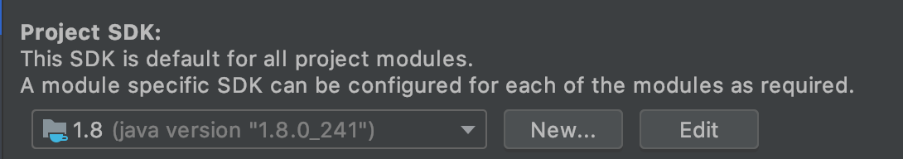

IntelliJ is our team choose of IDE, the screen shot is as following: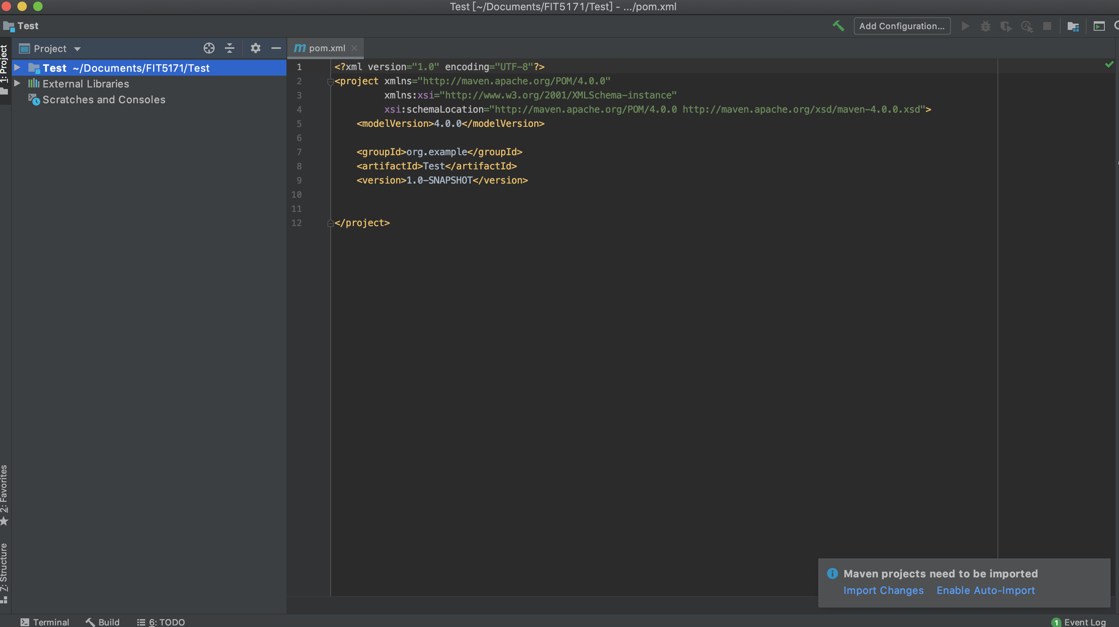

Next, we have set up our GitHub repository as shown as the following picture

And Finally, we import the base code provided by Mood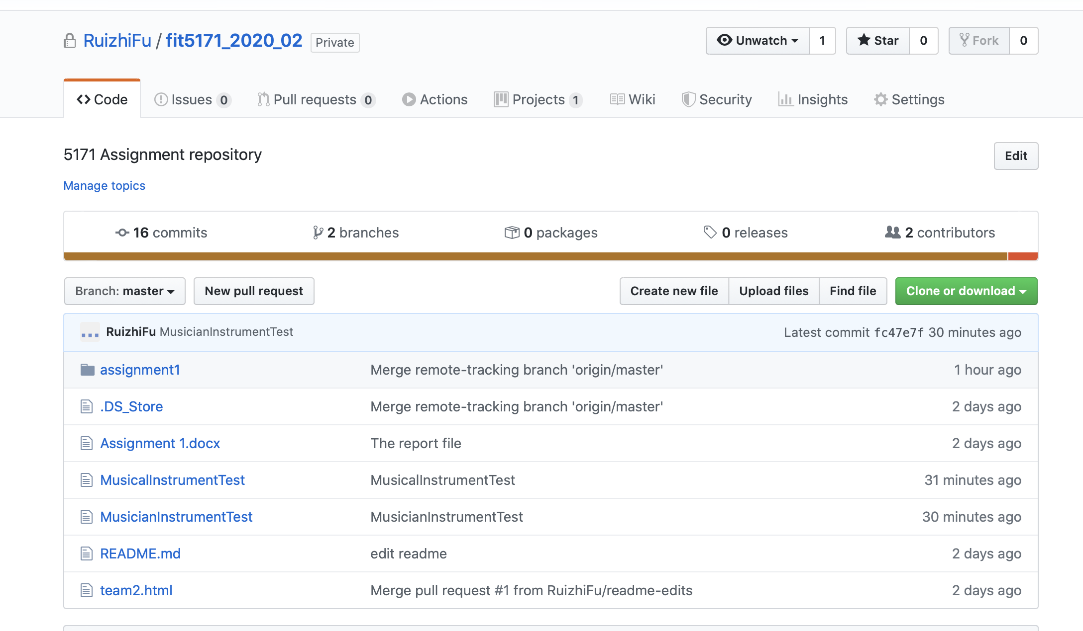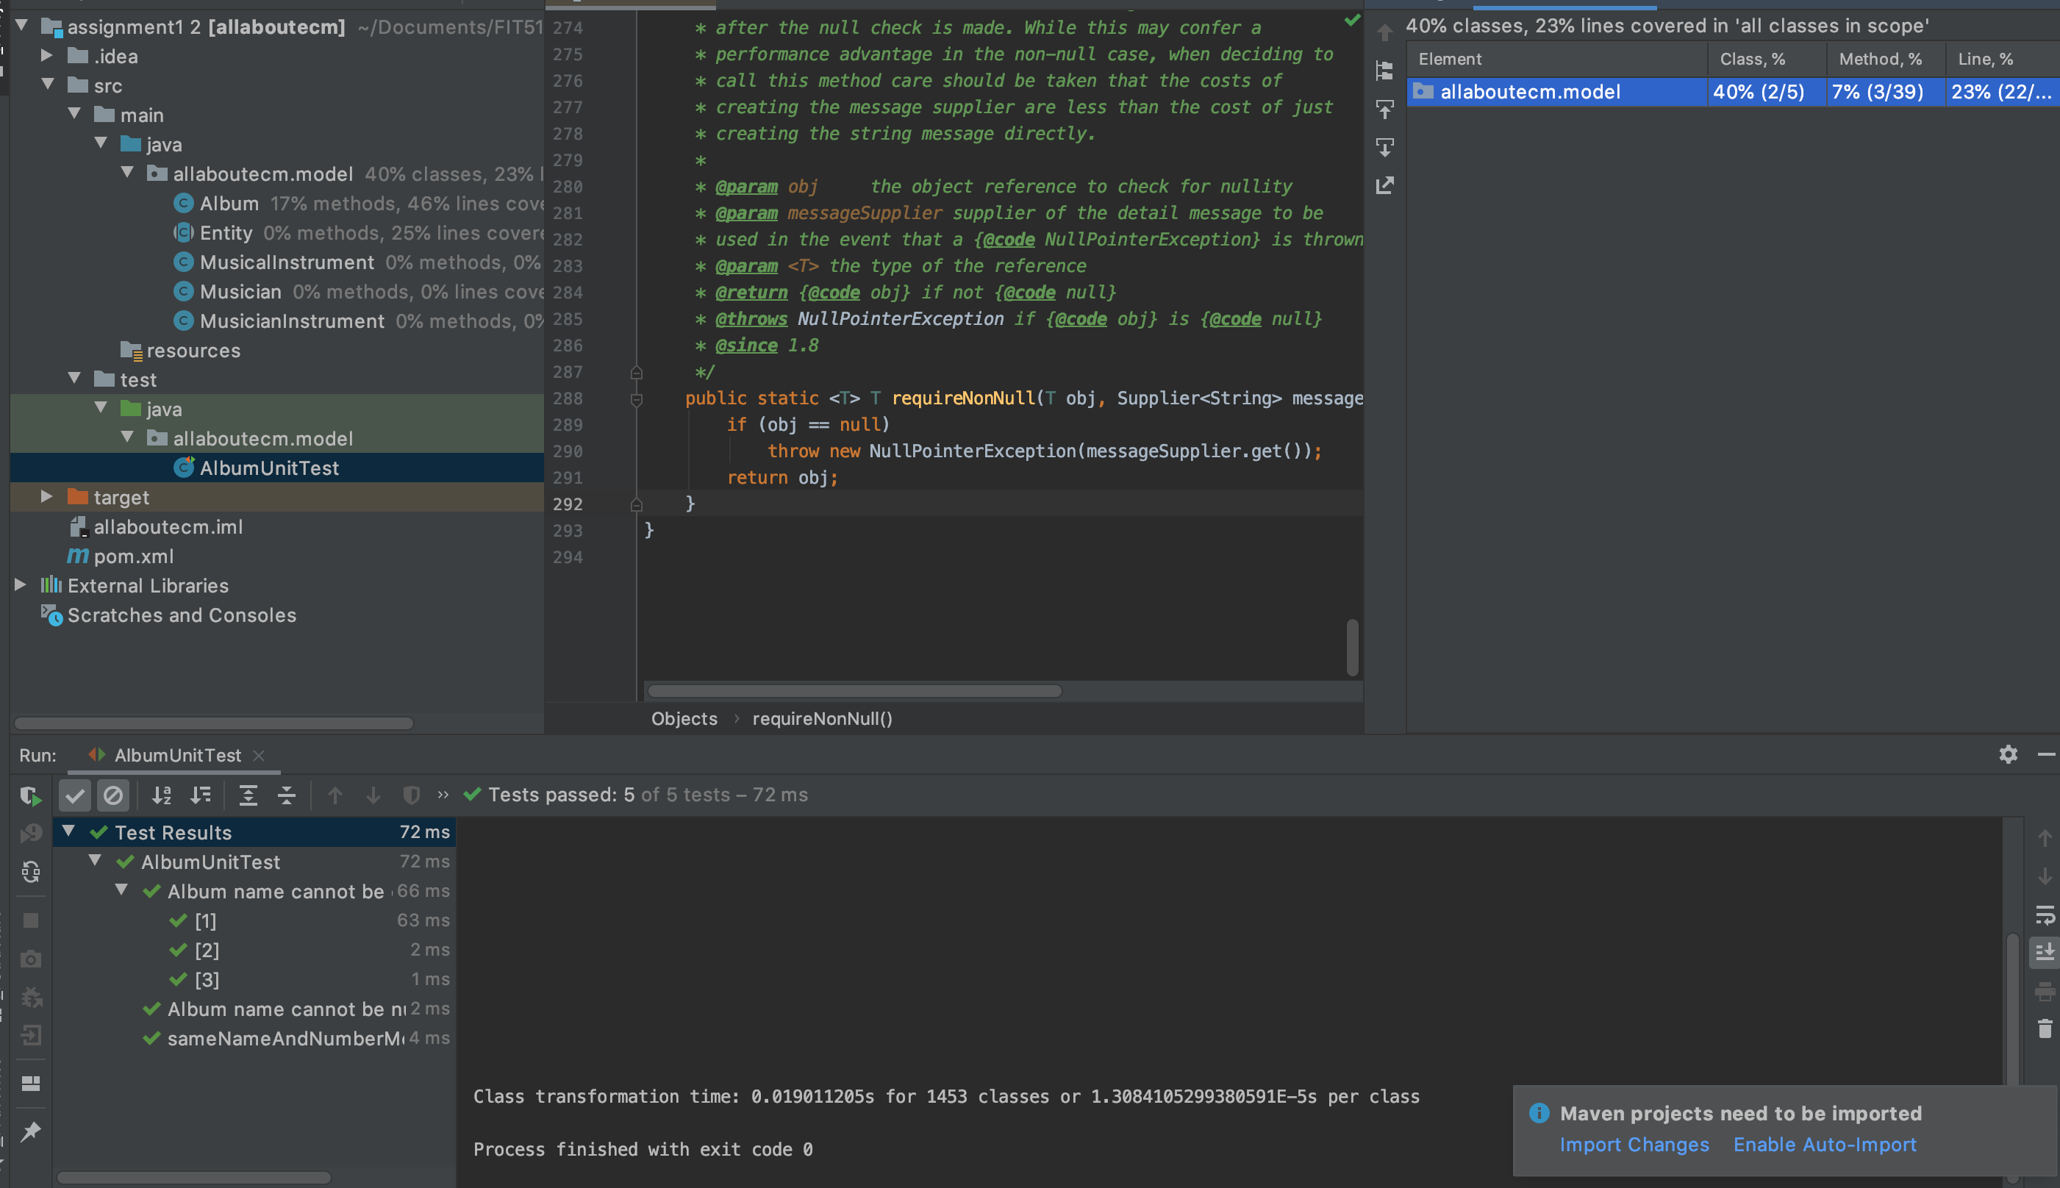le, and we can compile and run the test using Maven successfully.

Also, we can update and commit our team’s source code to our GitHub repository by GitHub kraken.